09/09/2024

New game proposal.

* Develop on flutter, mobile game.
* 2.5 d environment
* 3d objects

Attractive points:

* Choice Tree
* Freedom: building base
* Inventory system
* Leveling up
* Physix engine
* Specific hitbox and scars

Theme:

Unending quest (mobile in app purchase & ads)

Trade but in space:

Start in milky way galaxy:

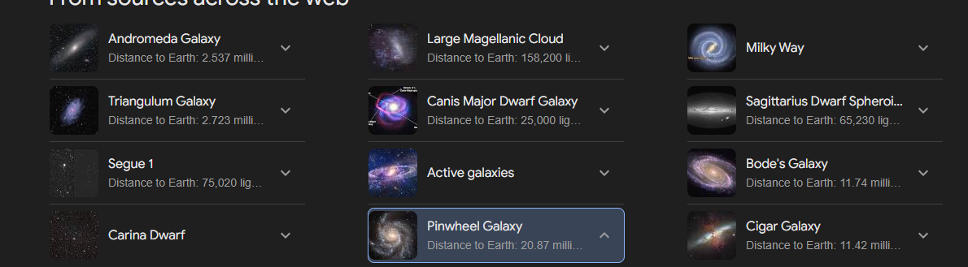

Unlock galaxies with updates:Watch cowboy bepop and draw inspiration

Trade winds

Perk tree backstory: trader, pirate, bounty hunter

Puzzles for each backstory and treasure hunting on specific islands.